Title in English
Title in Spanish
Title in Portuguese

Author https://orcid.org/0009-0008-0000-xxxx
Author https://orcid.org/0000-0001-xxxx-0000
Author https://orcid.org/0000-xxxx-0000-0006

Received: ____/_____/2025
Accepted for publication: ____/____/2025

Abstract

The abstract should present the relevant points of the article in a concise and concise manner, and should include the purpose, relevance and originality of the methodology, the results and conclusions, and/or final considerations. (up to 120 words) Palatino Linotype font, size 11. Justified text. The keywords should appear immediately below the abstract, preceded by the expression Keywords: followed by a colon, separated by a semicolon, and ended with a period. They should be written with the initials in lowercase, with the exception of proper nouns and scientific names.

Keywords: 3 to 5 keywords ABNT NBR 6028:2021

Resumen
El Resumen debe proporcionar una presentación sintética y concisa de los puntos relevantes del artículo, debe contener el propósito, expresar la relevancia y originalidad, la síntesis de la metodología, la síntesis de resultados y la síntesis de conclusiones y/o consideraciones finales. (hasta 120 palabras) Fuente Palatino Linotype tamaño 11 Texto justificado. Las palabras clave deben aparecer inmediatamente debajo del resumen, precedidas de la expresión Palabras clave: seguidas de dos puntos, separadas por punto y coma y finalizadas por un punto. Deberán escribirse con iniciales en minúsculas, a excepción de los nombres propios y los nombres científicos.

Palabras clave: 3 a 5 palabras clave ABNT NBR 6028:2021

Resumo

O Resumo deve fazer a apresentação sintética e concisa dos pontos relevantes do artigo, deve conter a finalidade, dizer a relevância e originalidade a síntese da metodologia, a síntese dos resultados e a síntese das conlusões e ou considerações finais. (até 120 palavras) Palatino Linotipo fonte tamanho 11 Texto justificado. As palavras-chave devem figurar logo abaixo do resumo, antecedidas da expressão Palavras-chave: seguida de dois-pontos, separadas entre si por ponto e vírgula e finalizadas por ponto. Devem ser grafadas com as iniciais em letra minúscula, com exceção dos substantivos próprios e nomes científicos.

Palavras-chave: 3 a 5 palavras chave ABNT NBR 6028:2021

Introduction (required item)

Initial part of the article, which should include the delimitation of the subject matter, the objectives of the research and other elements necessary to situate the theme of the article, written in Palatino Linotype (12) and spacing 1.5 throughout the text. Justified text. Margins: top and left 3cm, bottom and right 2cm. Indentation of the first line 1.25cm, containing the main ideas that guide the text of the article, objectives, research phase, methodological procedures, when applicable, etc.
Section title (topics) = title (subtitle)
Section: a section into which the text of a document is divided, containing matters considered related, in an orderly manner according to the subject. Justified text. Font: Palatino linotype, size 12. Spacing: 1.5. Margins: top and left: 3 cm, bottom and right: 2 cm. First line indent: 1.25 cm. When there are tables, these should be typed following the standard formatting of the text editor. Notes should be numbered and on the page itself. The acronym, when mentioned for the first time in the text, should be indicated in parentheses, preceded by the full name. Example: Brazilian Association of Technical Standards (ABNT). Acronyms with more than three letters are written in capital letters if they cannot be pronounced as a word, such as ABNT, BNDES, IPTU. Acronyms with more than three letters are written with only the initial capital letter, if they can be pronounced as a word, such as Ipesc, Celesc, Casan, Serasa, Engepasa, Unibanco, Univali, Unisul, Telesc, Embratur, Dort, Unesco, Incra, Fiesp, Bradesco, Besc, Anatel, Bacen, Bovespa, Cofins, Cosif, Dataprev, Dieese, Embratel, Infraero, Mercosul, Procon, Sebrae, Sesc, Senac, Senai, Udesc, Unicamp, Unicef, Ufir, Unimed. (recommended by the Brazilian Academy of Letters-ABL)
Quotes longer than 3 lines should be indented from the left margin by 4 cm. Text in Palatino, size 11. Single spacing. Justified. Font size 11 and single spacing are recommended, standardized in citations for the entire article. Notes, captions and fonts for illustrations and tables should be in a smaller and uniform size. (Author, year, p. page number). (ABNT 10520/2023).
Justified text. Font, Palatino linotype, size 12. Spacing 1.5. Margins: top and left 3 cm, bottom and right 2 cm. First line indent 1.25 cm. When there are tables, these should be typed following the standard formatting of the text editor. Notes should be numbered and on the page itself.

Section subtitle (subtopics)

Palatino Linotipe (12)

NOTE: Illustrations, tables and graphs must be included in the body of the text, following the model below:

Map 1 - Vector world base

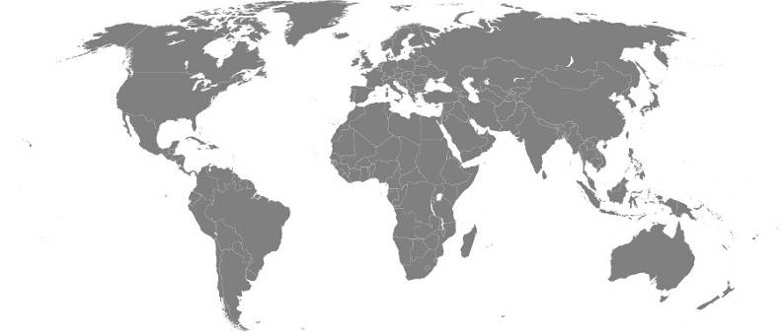

Source: author (xxxx)

Text

Graph 1-Information with data about the city of xxxxxxxx

Source: author (xxxx)

Text text
Text
Text text
Text

Table 1- Table description.
Título
Títul o | Coluna 1 | Coluna 2 | Coluna 3
Linha 1
Linha 2
Linha 3
Linha 4
Source: author (xxxx)

Text text
Text
Text text
Text

Chart 1 – Characteristics of the river basins under study.
 | Área da bacia  (Km²) | Nascente | Foz | Comprimento (Km) | Escoamento médio anual  (10⁶ m³)
Minho | 000
Douro | 00
Vouga | 0
Source: author (xxxx)

Text text
All illustrations must be considered according to their type presented in the text of the article. EX: map 1- graph 1-, photo 1-, and table 1- as such must be mentioned in the body of the text of the article and as close as possible to the illustration, in parentheses (table 1) (table 1), according to the standards of ABNT 14724/2011 and ABNT 6022/2018
Final considerations

Palatino Linotype (12)
Final part of the article in which considerations corresponding to the objectives and/or hypotheses presented in the body of the text are presented

References

Must be prepared in alphabetical order. Palatino Linotype (11) According to ABNT Standard. 6023/2018

Reference models:

Book:
ROCHA. A. A.; FERRAZ, A. E. de Q. Atlas geográfico de Vitoria da Conquista. Vitória da Conquista: Edições do autor, 2015.
SILVA, J. A.. Instruções para autores. X ed. Cidade: Editora, 1954. Xx p.
Book Chapter:
SILVA, J. A.; SANTOS, P. A.. Instruções para autores. In Instruções para autores. X ed. Cidade: Editora, 20xx. Xx p.
Article:
ANGELI, . G. A. S. .; AMORIM, M. C. de C. T. . . Daytime and nighttime surface heat islands: a representative analysis of the dry and rainy seasons in Presidente Prudente – SP . Geopauta, [S. l.], v. 8, p. e15585, 2024. DOI: 10.22481/rg.v8.e2024.e15585. Disponível em: https://periodicos2.uesb.br/index.php/geo/article/view/15585. Acesso em: 26 dec. 2024.
COLLISCHONN, E. . The extreme precipitation event of autumn 2024 in the Guaíba hydrographic region (RS). Geopauta, [S. l.], v. 8, p. e15684, 2024. DOI: 10.22481/rg.v8.e2024.e15684. Disponível em: https://periodicos2.uesb.br/index.php/geo/article/view/15684. Acesso em: 26 dec. 2024.
ROCHA, A. A. The Physical Geography in the Context of Global Environmental Changes: New Challenges and Perspectives. Geopauta, [S. l.], v. 8, p. e15567 , 2024. DOI: 10.22481/rg.v8.e2024.e15567. Disponível em: https://periodicos2.uesb.br/index.php/geo/article/view/15567. Acesso em: 26 dec. 2024.

Dissertations/Theses:
ROCHA. Instruções para autores. Tese de doutorado/Dissertação de mestrado apresentado ao Programa de Pós Graduação em Geografia da Universidade/Instituição de pesquisa, 20xx. Xxx p.

Acknowledgements

Only to funding agencies, if applicable
(Capes, CNpq, Fapesb, )

(if there is more than one author, indicate the contribution of each one here)
Authors' contributions:
Author 1; Preparation, discussion of results, bibliographic research, text review
Author 2: Supervision, final analysis of results and text review
Author 3 xxxxxxxxxxxxxxxxxx

Institution/university xxxxxxxx, city, state, country, email.
Institution/university xxxxxxxx, city, state, country, email.
Institution/university xxxxxxxx, city, state, country, email.

